Microsoft Learning Study Camp
Ishaan Rastogi
SQL Assignment
Part 1
Aggregate Functions
Q1. Find the average salary of employees in the employees table.
SELECT AVG(salary) AS average_salary FROM employees;
Q2. Count the number of employees in each department.
SELECT department_id, COUNT(*) AS employee_count FROM employees GROUP BY department_id;
Q3. Retrieve employee names and their corresponding department names.
SELECT e.employee_name, d.department_name FROM employees e JOIN departments d ON e.department_id = d.department_id;
Complex JOINs
Q4. Retrieve the names of employees who have a salary higher than the average salary.
SELECT employee_name FROM employees WHERE salary > (SELECT AVG(salary) FROM employees);
Q5. Retrieve the names of employees and their managers (use self-join).
SELECT e.name AS employee_name, m.name AS manager_name FROM employees e LEFT JOIN managers m ON e.manager_id = m.id;
Q6. Retrieve the salaries of employees along with the average salary of their department.
SELECT e.name AS employee_name, e.salary AS employee_salary, AVG(e.salary) OVER (PARTITION BY e.department_id) AS avg_department_salary FROM employees e;
CTEs (Common Table Expressions)
Q7. Use a CTE to find the second highest salary in the employees table.
WITH RankedSalaries AS (
SELECT salary, ROW_NUMBER() OVER (ORDER BY salary DESC) AS salary_rank FROM employees
)
SELECT salary FROM RankedSalaries WHERE salary_rank = 2;

Recursive Queries
Q8. Using a recursive CTE, retrieve the hierarchy of employees in the organization.
WITH RECURSIVE EmployeeHierarchy AS (
SELECT employee_id, employee_name, manager_id FROM employees WHERE manager_id IS NULL
UNION ALL
SELECT e.employee_id, e.employee_name, e.manager_id FROM employees e JOIN EmployeeHierarchy eh ON e.manager_id = eh.employee_id
)
SELECT employee_id, employee_name, manager_id FROM EmployeeHierarchy;
Advanced Aggregation
Q9. Find the top three departments with the highest total salaries.
WITH DepartmentSalaries AS (
SELECT department_id, SUM(salary) AS total_salary FROM employees GROUP BY department_id
)
SELECT department_id, total_salary FROM DepartmentSalaries ORDER BY total_salary DESC LIMIT 3;
Part 2
Q1. Create an ER diagram for a university database that includes entities such as Students, Courses, Instructors, and Departments. Define the relationships among these entities. Hint: Identify primary & foreign keys, and consider relationships like "enrolls," "teaches," and "belongs to."
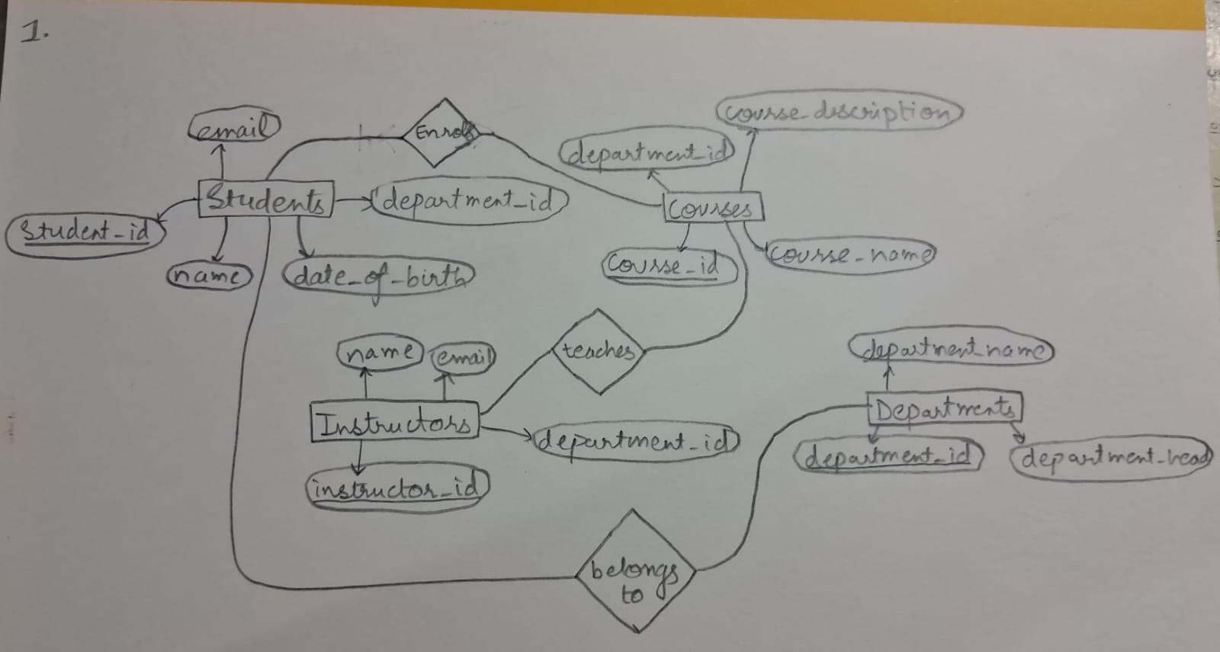
Q2. Convert the ER diagram you created into a relational schema. Clearly define tables, primary keys, and foreign keys. Hint: Break down the entities into tables and show how they relate through keys.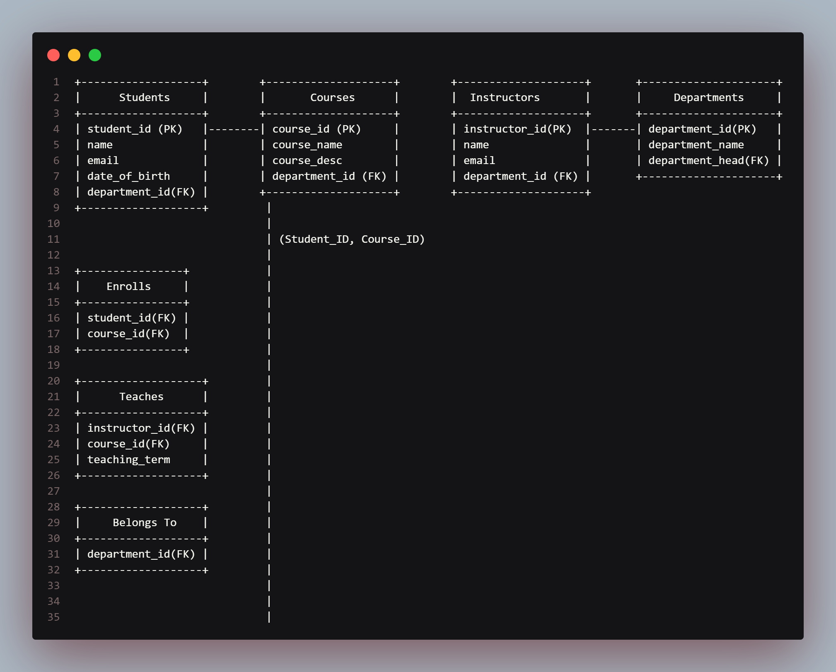
3. Given a table with the following structure, normalize it to 3NF: Employee (EmployeeID, EmployeeName, DepartmentID, DepartmentName, ProjectID, ProjectName, HoursWorked) Hint: Start by removing partial and transitive dependencies.
4. Design a simple transaction in SQL to transfer money between two accounts. Ensure that your transaction adheres to the ACID properties. Hint: Use BEGIN TRANSACTION, COMMIT, and ROLLBACK.
5. Discuss different types of indexes and their use cases.
MAIN QUESTION:
Design a small database for a library system, including entities such as Books, Members, Loans, and Authors. Provide the ER diagram, relational schema, and sample SQL queries to manage the system. Hint: Include queries for checking out books, returning books, and querying overdue loans.
CREATE TABLE Books ( book_id INT PRIMARY KEY, title VARCHAR(255), author_id INT, published_year YEAR, genre VARCHAR(100), available_copies INT, FOREIGN KEY (author_id) REFERENCES Authors(author_id) );
CREATE TABLE Members ( member_id INT PRIMARY KEY, name VARCHAR(255), email VARCHAR(255), membership_date DATE );
CREATE TABLE Loans ( loan_id INT PRIMARY KEY, book_id INT, member_id INT, loan_date DATE, return_date DATE, FOREIGN KEY (book_id) REFERENCES Books(book_id), FOREIGN KEY (member_id) REFERENCES Members(member_id) );
CREATE TABLE Authors ( author_id INT PRIMARY KEY, name VARCHAR(255), birthdate DATE, nationality VARCHAR(100) );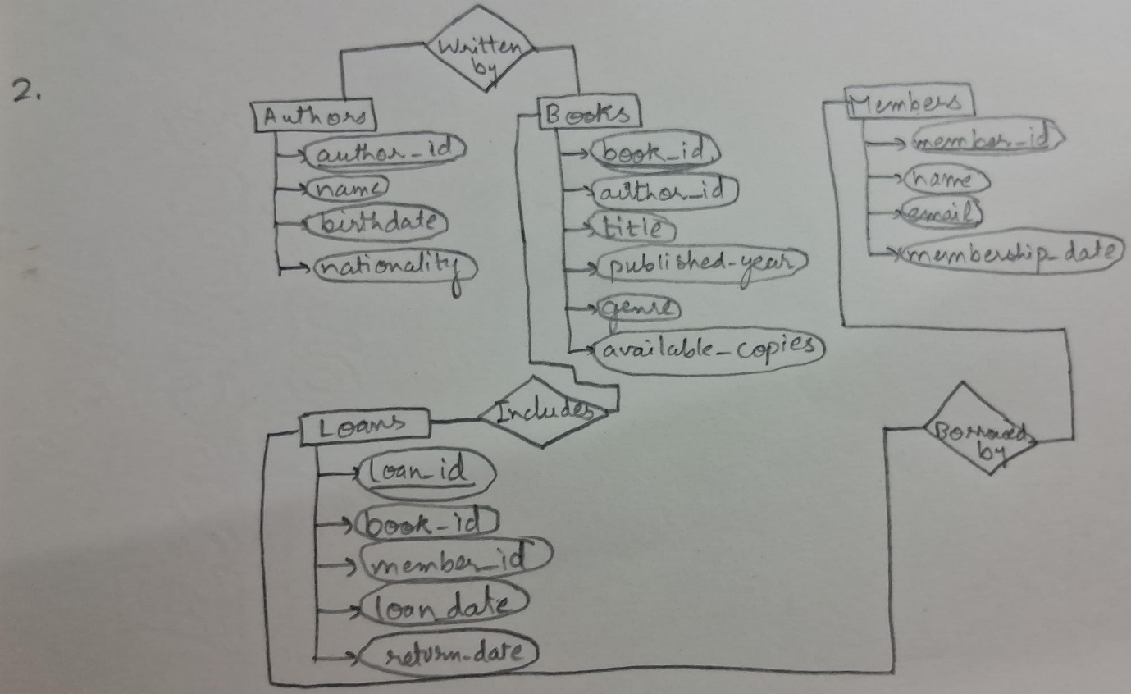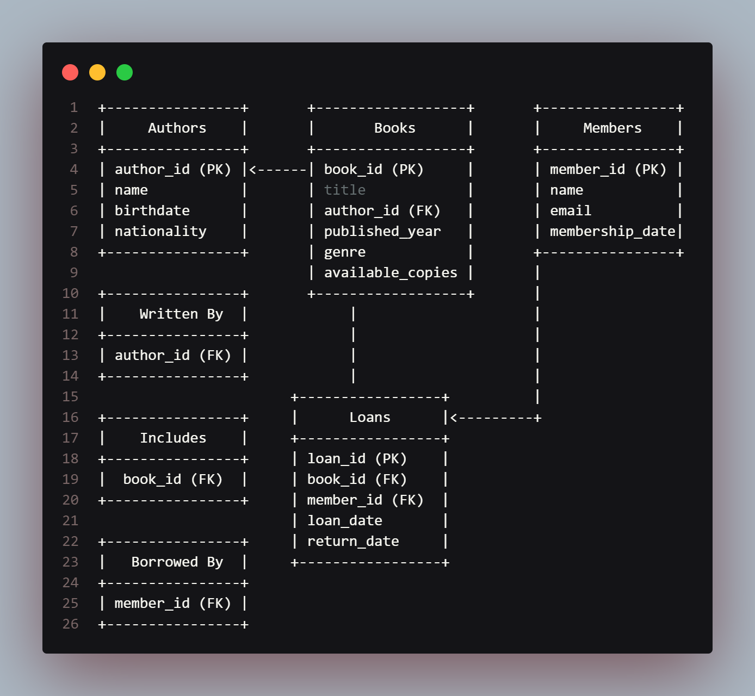
-- Insert a new loan record
INSERT INTO Loans (book_id, member_id, loan_date, return_date) VALUES (1, 101, CURDATE(), NULL);

-- Update the available copies in the Books table
UPDATE Books
SET available_copies = available_copies – 1 WHERE book_id = 1;

-- Update the return_date in the Loans table
UPDATE Loans SET return_date = CURDATE() WHERE book_id = 1 AND member_id = 101 AND return_date IS NULL;
-- Update the available copies in the Books table
UPDATE Books SET available_copies = available_copies + 1 WHERE book_id = 1;
-- Find overdue loans
SELECT l.loan_id, b.title, m.name, l.loan_date FROM Loans l JOIN Books b ON l.book_id = b.book_id JOIN Members m ON l.member_id = m.member_id WHERE l.return_date IS NULL AND CURDATE() > DATE_ADD(l.loan_date, INTERVAL 30 DAY);

